

Data Tokenization System
(DTS)

System Architecture Specification

Version 3.0
2012-04-30



Revision History
Version | Date | Author | Description
2.0 | 2010-05-27 | Sylvain Veillette | Version sent to client – following client comments
2.1 | 2010-06-11 | Sylvain Veillette | Version sent to client – following client additional comments before approval.
2.2 | 2010-06-18 | Sylvain Veillette | Version sent to client – following other client additional comments before approval.
3.0 | 2012-04-30 | Sylvain Veillette | Document update to reflect implementation completed as per DTS Phase 2 project and Release 2, 3 and 6 of the PCI-DTS program.  Include some Release 5 planned implementations.
Table of Contents
1. Introduction 5
1.1 Document Objective 5
1.2 Document Scope 5
2. System Architecture Specification 6
2.1 Use Case Scenarios/List of events 7
2.2 Conceptual View Model 8
2.2.1 Conceptual model Diagram 8
2.2.2 Conceptual model description 9
2.2.2.1 Cardholder Data Environment (CDE) 9
2.2.2.2 Data Tokenization System (DTS) 9
2.2.2.3 Authentication Service 9
2.2.2.4 DTS consumers 9
2.2.2.5 DTS Gateway services 10
2.2.2.6 IVR Servers 10
2.2.2.7 DTS parameters Data Store 10
2.2.2.8 RSA Tokenization System (RTS) 10
2.2.2.9 DTS-EDX Gateway 10
2.2.2.10 External 3rd parties 11
2.2.2.11 Audit logs 11
2.3 Process View Model 12
2.3.1 BSS Client Desktop Tokenization request 12
2.3.2 Process of a de-tokenized and forward request for a payment batch file 13
2.4 Development View Model 14
2.4.1 Component Model Overview 14
2.4.2 Service Oriented Architecture and Design 15
2.4.3 Logical Tiers and Components Description 15
2.4.4 SOA Service and Web Tier 15
2.4.5 Model and Business Tier 16
2.4.6 Integration and Connector Tier 16
2.4.7 Generic design and BSS application mapping rules 16
2.4.8 DTS stateless services 16
2.4.9 DTS AJAX Web plug-in 17
2.4.10 WebSphere Application Server Network Deployment 17
2.4.11 DTS Security - Reverse Proxy, Authentication and SSL 19
2.4.12 DTS SOA Service – Tokenization 21
2.4.13 DTS Service - Batch De-Tokenize 22
2.5 Infrastructure View Model 24
2.5.1 Production environment 24
2.5.2 Server components 25
2.6 Glossary 27

Introduction

Document Objective
Produced at the very first stage of the DTS project, the objective of this document was initially to provide Bell Canada and CGI project team members with details on the System Architecture Specification to align and support the System Design Specification during Phase 1.
Reaching the end of the DTS final implementation, and as more details can be found in other technical documents, the objective of the present revised version of this document is more to describe the overall system architecture implementation.

Document Scope
The present document describes from an architectural point of view the Data Tokenization System (DTS) at its actual state of implementation.
For more details on the DTS system implementation, please refer to the following documents:
- Data Tokenization System – System Design Specification
- DTS-EDX – System Design Specification
- Interface Design - DTS Online Service
- Interface Design - DTS Tokenization JS Plug-in
- Interface Design - DTS Online Web Application
- Data Tokenization System - System Environment Specification

System Architecture Specification
The complexity of a system architecture should not be forced on a single diagram or description. This makes it easier to understand the overall solution. Furthermore, different stakeholders can have their concerns addressed by different views which help communication of the architectural solutions. The following diagram illustrates four views and, for each one, identifies a typical stakeholder and the corresponding area of concern. The diagram also shows the System Design Specification at the center of those four views. The System Specification can also be considered a fifth view.

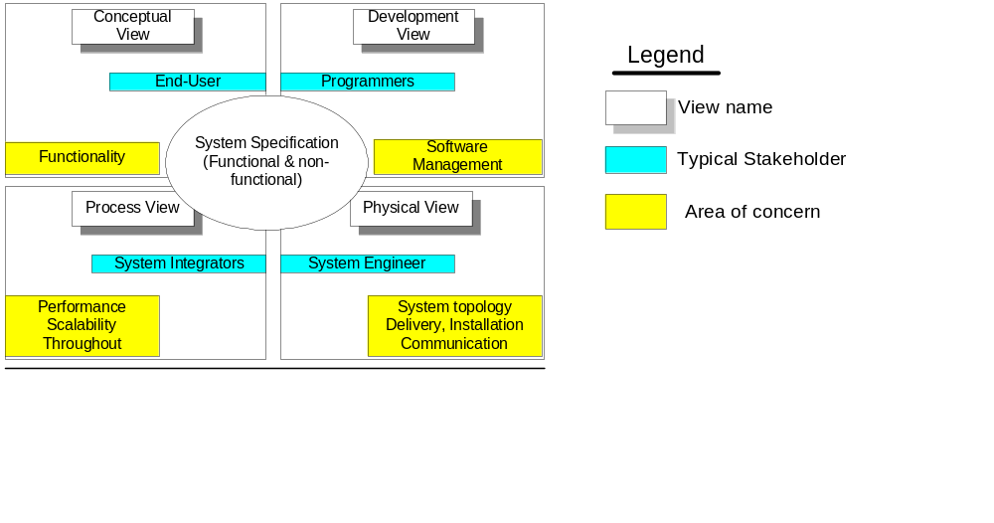

Use Case Scenarios/List of events
The following table lists the use cases supported by the DTS system.

Use Case | Description | Serviced by | End state | Transition  (Interim solution before End State) | Conversion  (Initial integration process)
Internet client desktop request to DTS Online services
UC01 | Tokenization | DTS | X
ICN intranet desktop request to DTS Online services
UC02 | Tokenization with PAN encryption | DTS | X
BSS server request to DTS Online services
UC03 | Tokenization | DTS |  | X
UC04 | De-Tokenization and authorization | DTS-PVS | X
UC05 | De-Tokenization and payment | DTS-PVS  or  DTS-CTIMG | X
UC06 | De-Tokenization and credit check | DTS-PVS  or  DTS-ESB | X
UC07 | Tokenization with PAN encryption (Future) | DTS | X
BSS server request to DTS batch functions
UC08 | De-Tokenization of batch file and forward | DTS | X
UC09 | Lookup of batch file and forward | DTS | X
UC10 | Tokenization of batch file and forward | DTS |  |  | X

Conceptual View Model
The conceptual model exposes the interactions of the end-user with the system. Since the Data Tokenization System (DTS) is more specifically a framework integrating different systems, this section is used to present a summary of the interactions involved in the different credit card handling business functions addressed by the solution.

Conceptual model Diagram

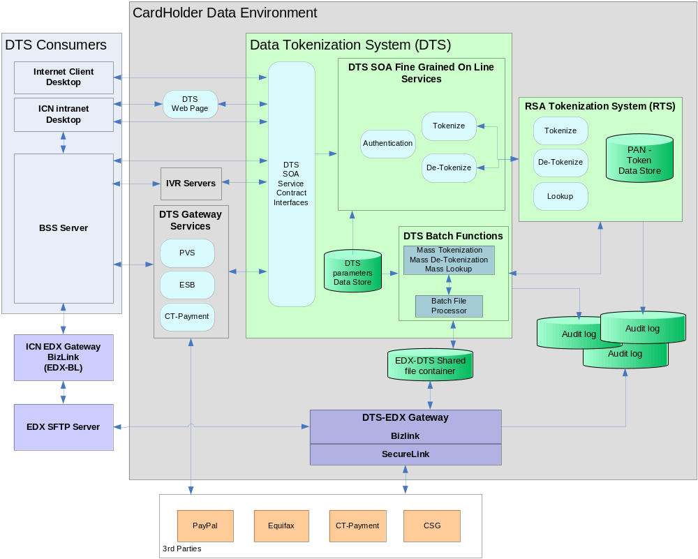

Conceptual model description

Cardholder Data Environment (CDE)
The CDE is a secure environment isolated from the standard BSS operating environments and networks in order to protect the credit card holder information processing, more specifically the Primary Account Number (PAN). This isolation is one of the PCI-DSS compliance criteria.
In fact, the CDE is segregated in two distinct network zones:
- The CDE Server farm (CDE-SF) hosting the backend components like the DTS application servers and databases
- The CDE DMZ hosting front end components facing both the Bell Internal Communication Network (ICN) and the Internet, like the 3rd party gateways
For more information about component distribution across the CDE Server farm and the CDE DMZ, refer to the “Data Tokenization System - System Environment Specification” document.

Data Tokenization System (DTS)
The DTS provides generic functions to process the different requests coming from consumers (ref. Use case scenarios, section 2.1). Those functions are provided through different interfaces:
- JavaScript : On line tokenization
- Web Service : On line tokenization and de-tokenization (synchronous)
- Web Page (On line tokenization)
- Batch file transfer (Batch de-tokenization and batch lookup)

Authentication Service
Any online request to DTS, either from a browser or an application server (consumer) is submitted to the authentication service. Based on specific authentication information provided as part of the request by the consumer, this service verifies if such a request is valid and authorized, and only then forwards the request to DTS Online services. DTS support 2 methods of authentication:
- Encrypted passkey generated by the consumer based on a symmetric key aka “Shared Secret”
- Client certificate issued from a Certificate Authority supported by DTS
Note that the Bell ICN SiteMinder system first control the access to the DTS Web Page which in turn generate a passkey to be validated by DTS. (See section 2.4.11 for more detail on the authentication process).

DTS consumers
DTS Online services can be invoked by the following consumer types:
- External Internet client desktop running a browser-based DTS JavaScript called from within "DTS authorized" Bell Web application
- Internal BSS User Desktop running a browser-based DTS JavaScript called from within "DTS authorized" Bell Web application
- Internal BSS User Desktop accessing the DTS Web page for ICN user session having the required privileges to get through SiteMinder access control
- Internal BSS application server running a "DTS authorized" Bell application
- DTS Gateways, although part of the overall DTS solution, are also considered as DTS Consumer
The on line invocation is granted and forwarded to DTS by the authentication service only for consumers providing the right authentication information including a dynamic valid pass key.
DTS batch functions can also be invoked by Internal "DTS authorized" BSS application but only through the ICN EDX Gateway (EDX-BL) to the DTS-EDX Gateway via a SFTP server.

DTS Gateway services
The DTS Gateway Services are acting as proxies for BSS requiring online services from 3rd party like payment, authorization and credit check. These services mainly substitute tokens by PANs through a call to DTS service before forwarding the BSS request to the target 3rd party. Responses back to the BSS requesters are also managed by the DTS gateway services.

IVR Servers
IVR servers are an extension of the ICN IVR infrastructure hosted in the CDE environment in order to address specialized technical requirements to support secure PAN capture through Dual-Tone Multi-Frequency (DTMF) entry over a telephone handset type of device. Once captured, the PAN is sent to DTS for tokenization and the token is then return to the ICN IVR system.

DTS parameters Data Store
The processing orchestration of the requests (both on line and batch) is mainly based on rules and parameters held in the DTS Data Store. For example, a request for a de-tokenization is being processed based on parameters specific to the consumer like the method of authentication. The DTS Data store also contains some parameters (eg. Accepted credit card type) used to do validation before processing the requests.
As another example, for DTS batch functions request, rules and parameters allow the determination of file structures for de-tokenization.

RSA Tokenization System (RTS)
The RSA Tokenization System, from RSA the Company, is distinct and complementary to the DTS System. It is an Application Programming Interface (API) component that mainly provides PAN tokenization, de-tokenization and lookup functionalities within the CDE-SF for batch and online transactions. It stores the PAN-to-Token mapping in the PAN-Tokens Data Store in an encrypted form using a key provided by the RSA Key Manager appliance (RKM).

DTS-EDX Gateway
The DTS-EDX gateway, as the RTS, is a distinct and complementary component to the DTS residing in the CDE. It is in fact an instance of the EDX system used in Bell for secure file transfers with external 3rd parties.
The DTS-EDX gateway has 2 main functions:
- Manage bi-directional file transfers between BSS applications and DTS, through a secure channel established between the DTS EDX gateway Bizlink component and the EDX Gateway BizLink on the ICN, for batch file processing requests to DTS and any authorized consumer (through EDX profile configuration)
- Manage bi-directional file transfers between DTS and 3rd parties through the EDX SecureLink Proxy
The files exchange between the DTS-EDX gateway and DTS is done using the EDX-DTS shared file container.

External 3rd parties
External 3rd parties are external entities having business agreements with Bell to provide credit and payment services such as:
- Credit card authorization
- Credit card payments
- Credit screening
All batch requests to these 3rd parties are managed through the DTS-EDX gateway in conjunction with the DTS batch functions.
Online requests from DTS Consumers are processed by the DTS Gateway services.

Audit logs
In support to PCI-DSS compliance, processing steps within the CDE are logged by the different components into log files. The formats of the different log records allow complete reconstruction of the end-to-end transmission and processing of any credit card transaction to support required tracking, troubleshooting and investigation activities. The logs are stored at the local file system level. The Bell Arcsight system is responsible to regularly extract those logs to the Bell repository for storage, query and reporting facilities.

Process View Model
The following sections give an overview of two processes:
- Online tokenization to summarize online components interactions
- Batch de-tokenization to describe process flow from a BSS to a 3rd party
Refer to the System Design Specification documents (DTS and EDX) for a more detailed description of all the PCI-DTS processes.

BSS Client Desktop Tokenization request
From a browser perspective, the main steps are:
- From the BSS Client browser, the BSS Web page downloads the DTS JavaScript Plug-in to embed it at the BSS User Interface level.
- Once the Pan is entered by the user, the JavaScript is called to send a request to the DTS tokenize service in order to invoke the DTS Web application (servlet) which is the entry point to the DTS. Prior to the service request, the DTS JavaScript Plug-performs a PAN validation (format and LUNH-10 check).
- Prior to reaching the DTS SOA Service, an authentication of the request is performed at the DTS level. The Authentication is based on an encrypted passkey generated by the BSS application using the pre-established symmetric key with DTS (aka Shared Secret).
- DTS validates if the request format is valid (schema check).
- DTS logs the transaction.
- DTS performs a PAN validation (Token Type determination).
- The Tokenization fine grained service is invoked to perform the tokenization request.
- DTS calls the RSA System via the RTS API in order to get the appropriate token from the PAN.
- DTS returns the token response to the BSS Client browser via the SOA API.

Process of a de-tokenized and forward request for a payment batch file
This batch process starts from DTS-EDX, here are the main steps:
- Once DTS-EDX receives a BSS file from EDX-BL on the ICN to be processed, DTS-EDX puts the file containing the tokens into the shared file container.
- DTS-EDX notifies DTS via JMS that a file is in the inbound folder ready to be processed.
- DTS receives the message that is put into the JMS queue.
- DTS retrieves the file from the EDX-DTS shared file container.
- DTS parses the tokens to de-tokenize from the file based on the rules and parameters kept in the DTS parameter data store.
- DTS invokes RSA by sending, per token type, the list of the tokens to be de-tokenized.
- RSA returns the PANs to DTS.
- DTS then uploads the file containing the PANs into the outbound folder.
- DTS-EDX checks at a regular basis the file (de-tokenized) in the outbound folder.
- DTS-EDX sends the file to the associated 3rd party based on the rules through the DTS-EDX SecureLink Proxy.

Development View Model
This section describes the various components of the Bell DTS SOA Service Architecture. The targeted audience is DTS developers and maintenance team members interested in a lower detail level of the key DTS SOA application components. The System Design Specification document provides more details about the SOA fine grained services design described in section 2.2 of the present document.

Component Model Overview
The diagram illustrated in Figure 1 provides an overview of the different DTS components and application tiers.

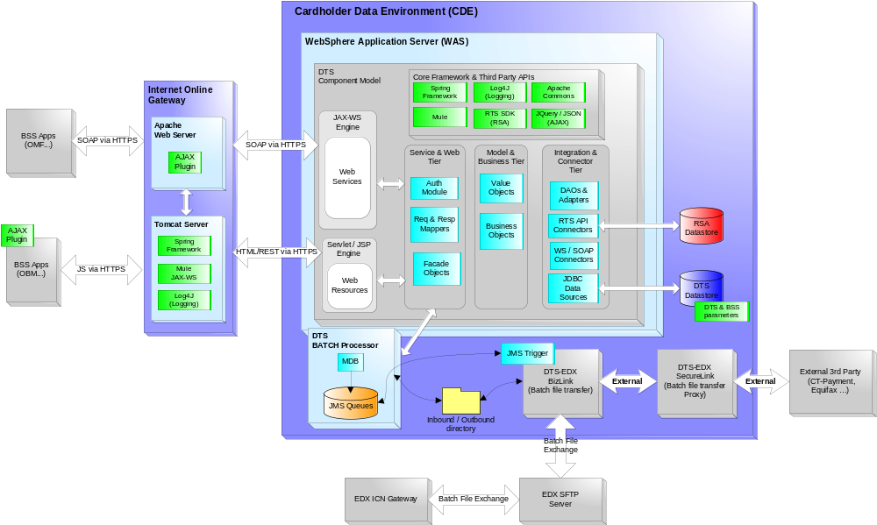
Figure 1 DTS: Component Model Overview Diagram

Service Oriented Architecture and Design
The Data Tokenisation System is using a standard Service Oriented Architecture approach conforming to Bell Canada’s best practices and approved by the Bell Enterprise architects.
(Note that this Service Oriented Architecture Service has not been integrated into Bell Canada’s SOA Enterprise Service Bus environment, identified as “B-SIDE”, as per requirements from Bell).
- Develop generic services that are Client/BSS application agnostic, enabling all necessary arguments to be provided by the consumer to orient the request process
- Avoid having rules embedded in the services unless specifically identified as a formal system requirement (eg. Determining authorized 3rd party for specific transaction)
- Expose services using open standards:
  - Jquery/Jsonp via HTTPS for browser requests
  - SOAP via HTTPS for server requests
- Provide a service model defining each service operation to ease Service utilization/integration for potential consumers, including :
  - Service contract documentation (Interface Design Document)
  - Web Service Definition Language (WSDL)
  - XML messages Schema
  - Generic plug-in for browser application consumers
- Implement an authentication mechanism to control usage of the exposed services
- Ensure proper granularity of services for ease of reusability and orchestration

Logical Tiers and Components Description
The logical tiers and the underlying key DTS components are briefly described within the sections below.

SOA Service and Web Tier
From an initial SOA service contract interface request, the Service and Web tier, receive parameter objects transformed by the Java EE Container (WAS) from an incoming SOAP message or plain text request, and fulfils the requirements of a DTS use case. This layer consists of 5 basic component types:

1. DTS connectors available for BSS applications to connect and invoke DTS services:
- JAX-WS (SOAP 1.1 & 1.2 via HTTPS) connector for server to server communication
- AJAX Servlet (Rest via HTTPS) connector for client browser to server communication
2. Shared inbound / outbound directory used by DTS-EDX for DTS batch processing services
3. Authentication and authorization modules used to authenticate and validate incoming client requests against the DTS BSS application mapping table
4. Request and Response object mappers used to map request parameters to proper Java objects as per Service Model
5. Facade objects used as a gateway to the core DTS business services and managed by the Spring Framework. The Facade components are responsible for orchestrating the calls to the various DTS business service objects based on the rules and parameters from the DTS configuration table.
Wiring and orchestration between the Web and Business tiers is managed using the Spring Framework.

Model and Business Tier
This layer contains the domain objects. Domain objects contain logic particular to the DTS business domain, essentially such as managing online tokenization and batch de-tokenization. The Value Object design pattern is used to encapsulate the business data. A single method call is used to send and retrieve the Value Object populated by the Business Object component.
Wiring and orchestration between the Business and Integration tiers is managed by the Spring Framework.

Integration and Connector Tier
The main objects found in this logical layer are called Data Access Object (DAO) and Adapter. The Data Access Object is mainly responsible for receiving requests from the Business Object to perform low level operation(s). The Adapter is responsible for wrapping the logic and the implementation of the connectivity to various downstream systems and CDE-SF internal systems such as the DTS Data store. Value Objects are once again used and populated by the DAO and returned to the Business Objects.
This layer also provides connector components that contain knowledge on how to communicate and exchange data between internal and external CDE-SF downstream systems.
Wiring and orchestration between the DAO and Adapter objects are managed by the Spring Framework.

Generic design and BSS application mapping rules
The DTS application design is built using a generic Service Oriented Architectural approach in order to minimize BSS application integration and coding effort. In order to help achieve this goal, the DTS application maintains an internal BSS application mapping rule table providing details such as BSS application ID and authentication method.
The mapping rule table is stored within the DTS data store and managed by the Spring Framework which provides simple and powerful plug-in approach to manage BSS application integration and business processes orchestration across the different application tiers.
The application design also follows standard Java EE specifications as opposed to any WebSphere Application Server (WAS) specificity. Such methodology is important in order to minimize effort of any future WAS upgrade or portability to another Java EE vendor.

DTS stateless services
All DTS SOA services invoked from BSS online and batch applications are stateless. This means DTS does not maintain or replicate any conversation state or “sticky” session with a BSS application. Active client sessions are maintained only within the BSS application itself and as per their existing architecture.
This architecture model provides simplified fail-over and redundancy capabilities via the CDE environment load balancers.

DTS AJAX Web plug-in
A set of generic JavaScript libraries are supported in order for BSS applications to invoke remotely the DTS tokenization services. JQuery and Jsonp are currently 2 AJAX frameworks. The leveraging of these frameworks also provides out-of-the-box support for the following browsers:
- Internet Explorer
- Firefox
- Safari
- Google Chrome
- Blackberry Browser on Blackberry
- Mini Safari Mobile Browser
The diagram illustrated in Figure 2 provides an overview of the AJAX Web plug-in interaction with the CDE environment

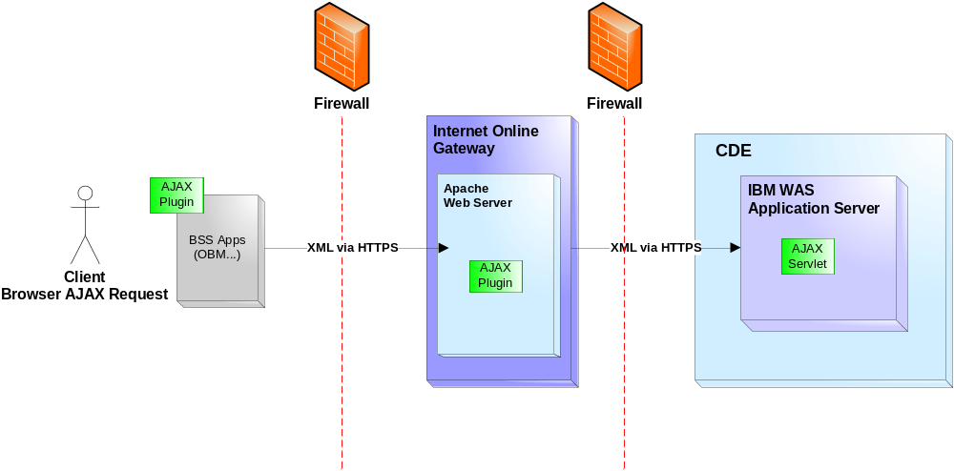
Figure 2 DTS: Generic AJAX Web plug-in

WebSphere Application Server Network Deployment
The DTS environment is built using 2 WebSphere Application Server (WAS) cells; one cell per geographical region. (Refer to section 2.5 for an overview of the redundant and distributed implementation of the DTS infrastructure). Each cell has a cluster of several Application Servers (cluster nodes). This implementation approach ensures proper scalability and flexibility in order to handle processing capability, load balancing, fail-over, version deployment and production troubleshooting.
A WAS cell is a group of related cluster nodes and their node agents constitute a cell. A cell contains a Deployment Manager from which all the administrative tasks for the nodes in that cell are handled. Deployment Manager for the cell has a master configuration repository that contains the configuration data for the nodes and servers within the cell. Configuration changes made at the cell level are propagated to the nodes and servers the next time synchronization occurs.

The diagram illustrated in Figure 3 provides a high level view of the DTS WAS Network Deployment model targeted for the production environment.

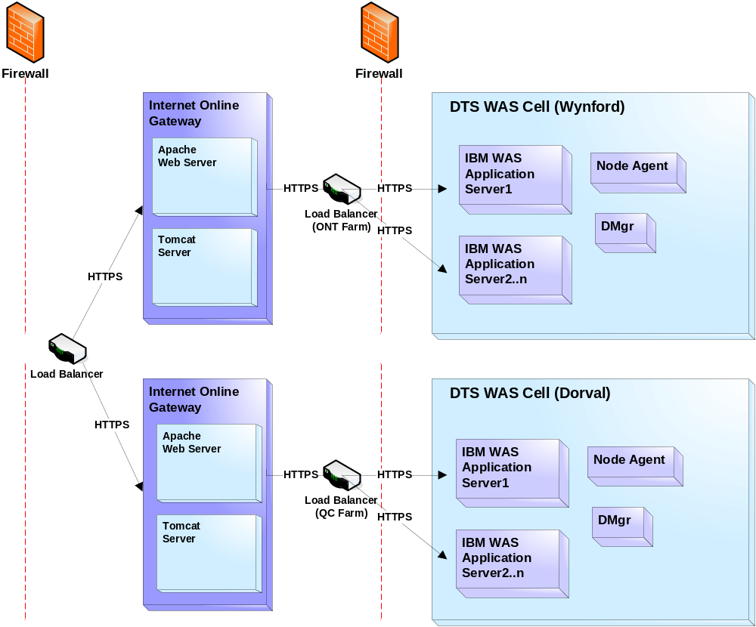
Figure 3 DTS: WAS Network Deployment Overview

DTS Security – Internet Online Gateway, Authentication and SSL
All servers or desktops connecting directly to CDE-DMZ need to be PCI-DSS compliant. In order to reduce the PCI-DSS scope within the Bell ICN, ICN gateways are implemented so that no BSS server or user desktop connects to the CDE-DMZ. The ICN Gateways servers act similar to a network 3 layer router as they only forward requests to the CDE-DMZ Internet Online Gateway (IOG) servers without terminating the SSL connection.
The IOG acts as a reverse Proxy to DTS. It intercepts incoming online requests coming through the ICN Gateway to extract attached credentials and performs authentication as follows:
- For encrypted passkey authentication, the Tomcat server extracts the authentication fields from the request and submits them to the DTS Authentication service for validation. Upon authentication success, Tomcat forward the integral request to DTS for processing.
- For Client Certificate authentication, the Apache certificate validation module verifies the following:
  - The certificate is issued by a pre-authorised Certificate Authority (Entrust)
  - The certificate is not expired
Upon certificate validation success, specific certificate information is forwarded to the Tomcat server which in turn extracts the authentication fields from the request and submits them to the DTS Authentication service for validation. Upon authentication success, Tomcat forward the integral request to DTS for processing.
- For the DTS Web Page access, the SiteMinder Agent validates ICN session credentials against the ICN SiteMinder Policy server and upon authorization, grant access to the DTS Web Page. The DTS Web Page generates a passkey and submits the request which is handled by the Tomcat Server to extract the authentication fields from the request and submits them to the DTS Authentication service for validation. Upon authentication success, Tomcat forward the integral request to DTS for processing.
The IOG then returns the completed request to the client, hiding the originating DTS Application server.
SSL is used as the standard encryption transport. Enabling SSL requires installation of Entrust SSL certificates within the Apache web servers and DTS application servers. SSL communication is used between Internet Online Gateway servers and DTS application servers.
Flooding attack concerns (Denial-Of-Service) on the reserve proxy itself will be addressed by the outer Firewall, NIDs and WAFs.

The diagram illustrated in Figure 4 provides an overview of the DTS Internet Online Gateway and Authentication.

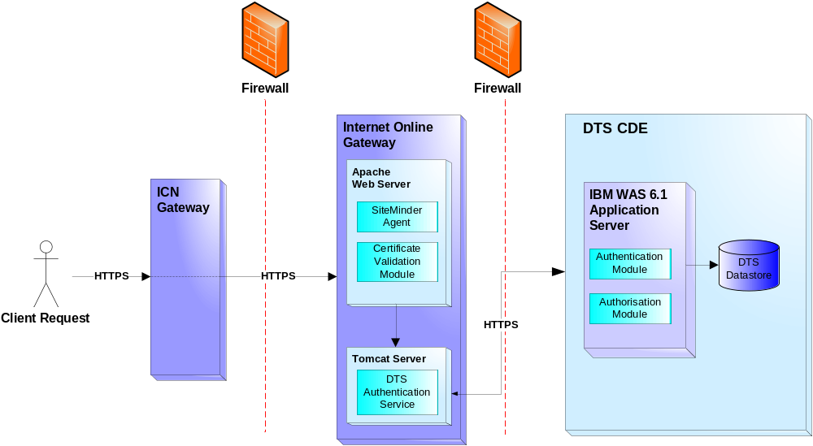
Figure 4 DTS: Internet Online Gateway and Authentication

DTS SOA Service – Tokenization
The diagram illustrated in Figure 5 provides an overview of the DTS component model of the SOA tokenization service with authorization invoked from a client browser request.
- The BSS client requests a PAN capture Web page.
- The client browser triggers a HTTPS request to download the DTS AJAX plug-in.
- The HTTPS request is forwarded to the IOG Apache Web Server and the JavaScript plug-in is uploaded to the client browser.
- The BSS client completes PAN data capture and triggers the JavaScript call.
- Through a SOA service contract interface request, the browser invokes the tokenize service from the AJAX plug-in and the client data along with a PAN is sent within a HTTPS / SSL packet to the IOG. The SSL packet is decrypted and passed from the Apache Web server to the Tomcat server.
- The Tomcat invokes the DTS Authentication service. Upon successful authentication Tomcat forwards the integral request to the DTS Servlet.
- The DTS Servlet invokes the Request Dispatcher which handles authentication and authorization via the BSS application mapping table initialized from DTS data store.
- The Request Dispatcher initializes the Tokenize Facade via Spring.
- The Tokenize Facade invokes the Authorization Business Object to validate the request for that BSS.
- The Tokenize Façade then invokes the Tokenize Business Object which invokes the RSA API to either generate a new token or get the existing one for the provided PAN and returns it to the Tokenize Facade.
- The DTS Servlet returns the token to the BSS application and client browser via the SOA API.

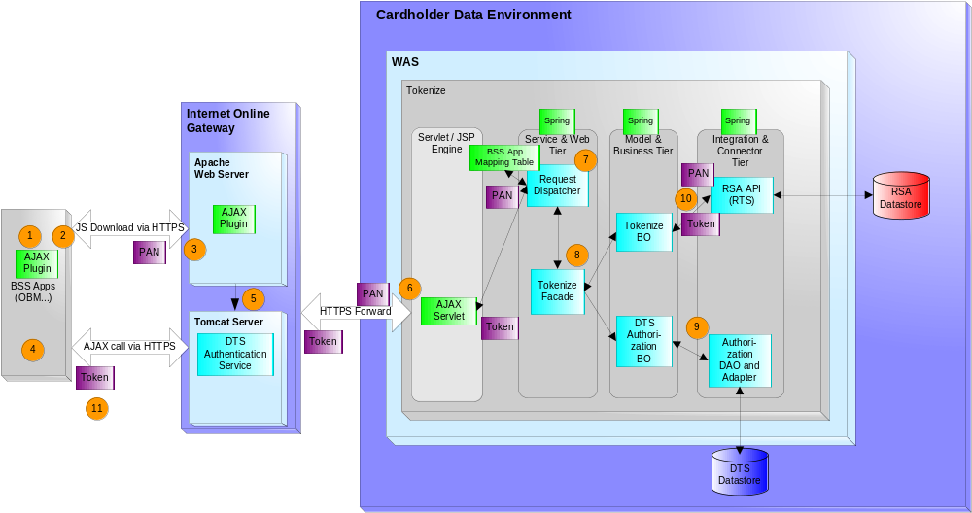

Figure 5 DTS: Tokenization

DTS Service - Batch De-Tokenize
The diagram illustrated in Figure 6 provides an overview of the DTS component model of the batch payment service.
- DTS-EDX receives a file from EDX Gateway (EDX-BL on the ICN) to be processed, this file transfer is done through the intermediate SFTP server.
- DTS-EDX copies the file containing the list of Tokens to de-tokenize into the common DTS batch inbound directory.
- DTS-EDX notifies DTS via JMS of an incoming flat file to be processed.
- DTS receives the message and puts it into the JMS queue which is then treated by the Batch Processor MDB.
- The Request Dispatcher handles authentication and authorization via the BSS application mapping table initialized from the DTS data store.
- The Request Dispatcher initializes the Batch Process Facade via the Spring Framework.
- The Mass De-Tokenize Business Object invokes the RSA Adapter to gets the list of associated PANs and returns the PANs up to the Tokenize Facade.
- The DTS Batch Processor generates the outbound file (with PANS) back to the outbound folder.
- DTS-EDX in turn checks at a regular basis for the expected de-tokenized file in the outbound folder and forwards it to the External 3rd party via the DTS-EDX SecureLink Proxy.

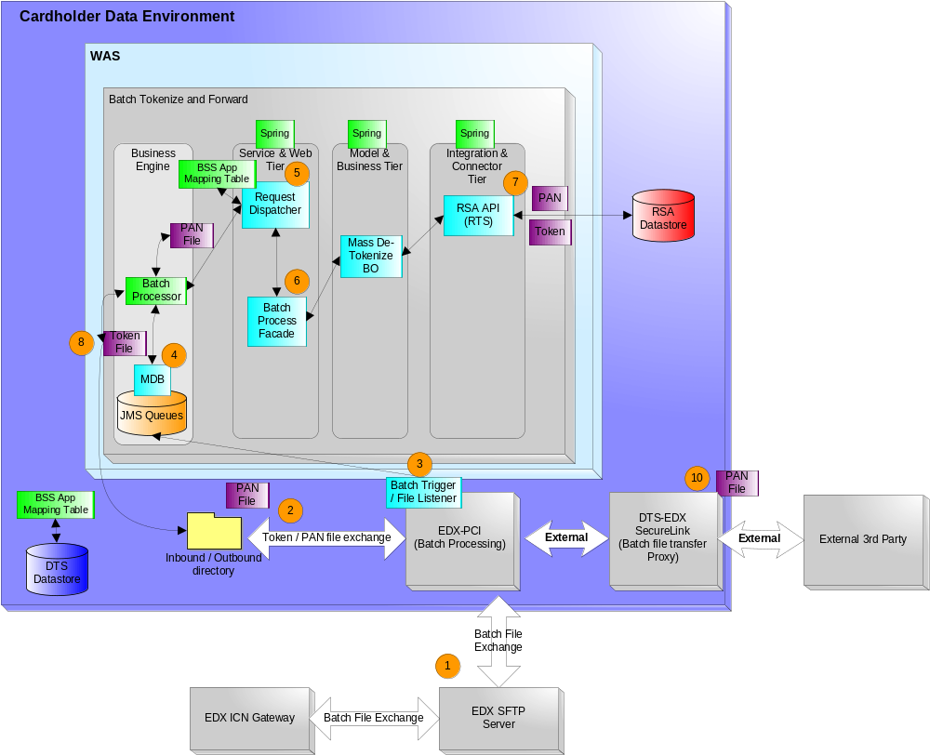
Figure 6 DTS: Batch De-Tokenize and Forward

Infrastructure View Model
The following sections give an overview of the server distribution model from the DTS CDE production environment. The infrastructure is based on both physical and virtual server components.
For a more comprehensive description of all DTS environments (e.g Production, Pre-Production and User Acceptance Integration), refer to the DTS Environment Specification document.

Production environment
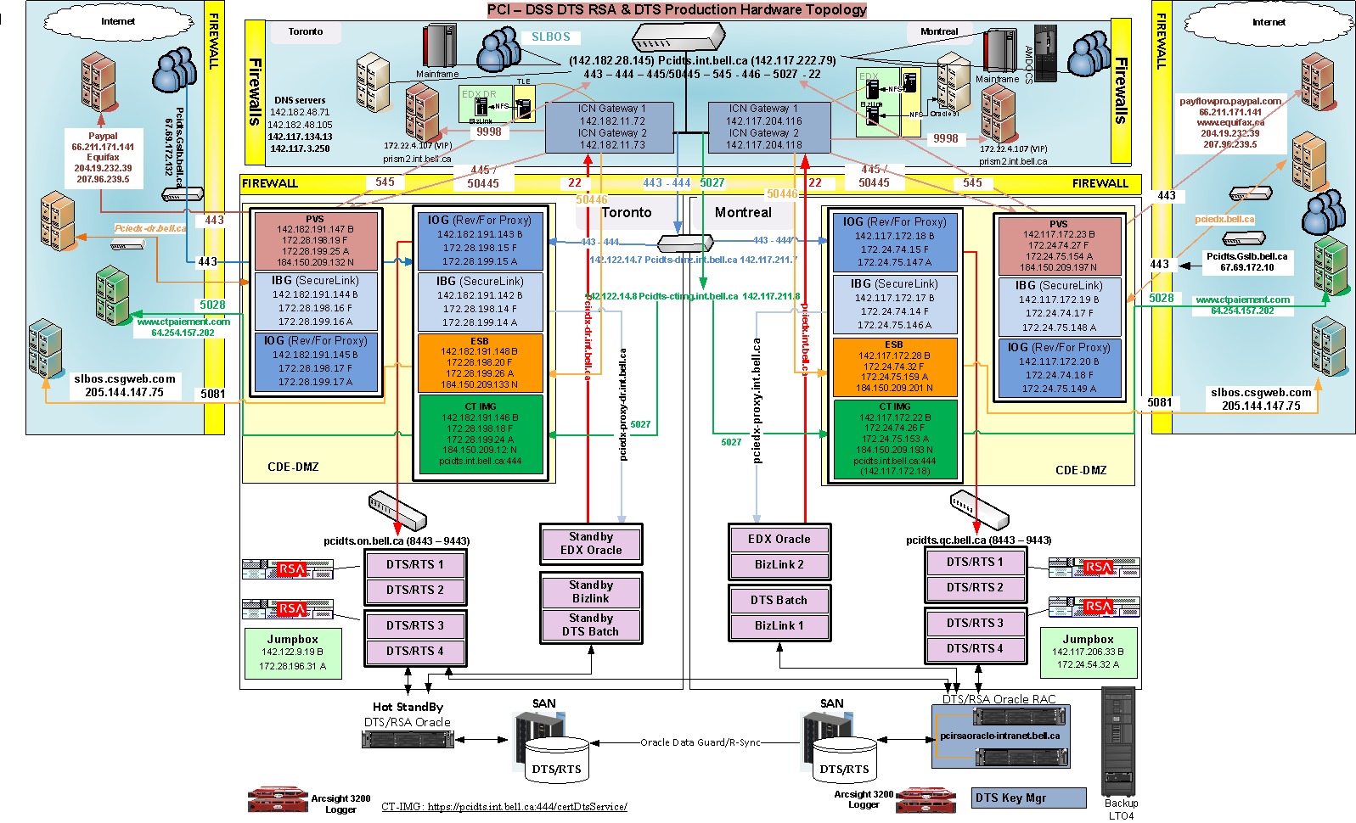

Server components
Server | Services | Description
ICN Gateway | Linux  - ICN request routing to CDE-DMZ servers | Acts as a network layer 3 router to route ICN incoming requests to CDE-DMZ facing servers based on port numbers. The data is passed as is with SSL termination and no decryption of payload to the Internet Online Gateway.  Also support routing from CDE-DMZ servers to ICN servers. The service is accessed via a Virtual IP across both regions in a round-robin method.
Internet Online Gateway | Apache  - Reverse-proxy service to DTS  Tomcat  - Authentication | Gateway for all requests from ICN BSS applications and User browsers going through the ICN Gateway.  2 steps process to reach DTS services :  - Authentication request to DTS  - Entire Payload forwarding to DTS
PVS | WebLogic Service Bus  - Payment and Credit Check | Act as a Gateway to 3rd Party for Credit Check and payment.
ESB | Oracle Service Bus over WebLogic Service Bus  - Payment and Credit Check | Act as a Gateway to 3rd Party for Credit Check and payment.
CT-IMG | Internet Information Services (IIS)  - Payment and Credit Check | Act as a Gateway to CT-Payment 3rd Party payment services.
DTS-RTS Application servers | WebSphere  - DTS application  - RTS API (RSA Tokenization Application)  - Oracle Clients to RSA and DTS Oracle DBs | Regional cluster with HA across WAS nodes and servers  Toronto Cluster is also the active fail over / DRP for its Montreal counterpart services.  DTS application functions include  - Authentication  - Authorization  - Validation  - RSA calls for tokenize and de-tokenize  - RKM calls for keys for PAN encryption on DB  - Logging  All DB updates will be done on the Active Oracle DB.
DTS/RTS Database | Oracle 11g with Real Application Cluster hosting 2 schemas  - DTS  - RSA  Live data replication to the Toronto DRP server using Data Guard. | DTS schema containing BSS data parameters, rules for DTS application processes and transaction logs.  RSA schema containing all PANs and associated tokens (all encrypted).
RKM Servers | RSA Key Manager Appliance Clustered within regions and Toronto acts as Fail over / DRP for Montreal  Replication of data is done for each cluster and across regions via internal services. | A closed appliance (“black box”) from RSA  Contains all the keys for encryption of all PANs and for LTO4 tape medias.
EDX PCI Oracle | Oracle 11g hosting the EDX Bizlink schema.  Veritas cluster with Bizlink servers.  Live data replication to the Toronto DRP server using Data Guard. | Contains all the processing rules for file transfer processes for Bizlink.
EDX PCI Bizlink | Inovis Bizlink application.  This service is also in Toronto but only used for DRP purposes and is NOT active. | Application to execute the transfer rules for each application/file requirements.
EDX SecureLink | Inovis SecureLink  - Proxy for batch files transfer.  This service is also in Toronto but only used for DRP purposes and is NOT active. | All file transfers to and from 3rd party such as CT-Payment and CSG, are channelled by this service.
DTS Batch | WebSphere  - DTS application  - JMS | Process all batch files for tokenization and de-tokenization
EDX ICN (BizLink) | As current | Will act as a gateway for all file transfers to and from the ICN BSS applications with its EDX component in CDE.
Backup | Netbackup  - LTO4 drives | Used for backup of all servers and data within the CDE  Only in Montreal as the DRP is based on live replication of data to the Toronto standby components.

Glossary
Term | Definition
API | Application Programming Interface
BO | Business Object
BSS | Business Support System
CDE | Cardholder Data Environment
CDE-SF | Cardholder Data Environment Server Farm
CDE DMZ | Cardholder Data Environnent De-Militarized Zone
DAO | Data Access Object
DTS | Data Tokenization System
EDX | Electronic Data Exchange
ESB | Enterprise Service Bus
HTTPS | HyperText Transfer Protocol Secure
ICN | Internal Communication Network
IVR | Interactive Voice Response
IOG | Internet Online Gateway
JMS | Java Messaging System
MDB | Message Driven Bean
NID | Network Interface Device
PAN | Primary Account Number
PCI DSS | Payment Card Industry Data Security Standard
PVS | Payment Validation Service
RKM | RSA Key Manager
SAN | Storage Area Network
SFTP | Secure File Transfer Protocol
SOA | Service Oriented Architecture
SOAP | Simple Object Access Protocol
SSL | Secure Sockets Layer
WAF | Web Application Firewall
WAS | WebSphere Application Server
WSDL | Web Service Definition Language
XML | Extensible Markup Language

